HONORS CHEMISTRY • UNIT 6
Stoichiometry
Use a balanced equation like a recipe: predict how much you need, how much you make, what runs out first, and how well the lab went.

TEACHER EDITION
Everything in a light-gray box or cell is an answer or model response. Teacher notes (misconceptions, demo ideas, discussion prompts, sources) appear in the heavy-bordered boxes labeled TEACHER NOTE. The pages follow the student packet, so they line up closely.

What we will learn
6.1 | Mole ratios
6.2 | Mass-to-mass stoichiometry
6.3 | Liters and particles (gas volume at STP)
6.4 | Limiting and excess reactants (BCA tables)
6.5 | Theoretical, actual and percent yield

By the end of this unit I can…
• Write mole ratios from a balanced equation and use them to convert between moles of two substances.
• Solve mass-to-mass problems using a mole map and show every unit.
• Convert between liters of gas at STP, moles, grams and particles.
• Identify the limiting reactant and calculate product made and excess left over using a BCA table.
• Calculate theoretical yield and percent yield, and explain why actual yield is smaller.
TEACHER OVERVIEW
Numbering: the homework folder labels these Topics 6.1–6.3, 5.4 and 5.5 (the last two are mis-numbered in the PDF). This packet is Unit 6 in the notes sequence with topics 6.1–6.5.
Every answer is computed by code from the balanced equation, using 2-decimal atomic masses (H 1.01, C 12.01, N 14.01, O 16.00, Na 22.99, Al 26.98, P 30.97, S 32.06, Cl 35.45, K 39.10, Fe 55.85, Ag 107.87, Ca 40.08) and 22.4 L/mol at STP. Unrounded values carry through; only the final answer is rounded to the sig figs of the given data. If your class uses different masses the last digit may differ.
Homework quirks: 6.1 #5 writes hydrazine as N₂H₂ (real hydrazine is N₂H₄; the packet keeps the homework formula so the key matches). 6.3 #3 calls NaN₃ “sodium nitride” (it is sodium azide). The 6.3 sub-parts are lettered b, e–j in the PDF; the packet renumbers them. 6.3 #1 needs STP assumed. 6.5 #2 gives “10 grams” of AgNO₃, treated as 2 s.f. 6.5 #3 as written (11.3 g actual) gives a percent yield over 100 % (theoretical is 8.78 g), so the packet uses 7.30 g.
Misconceptions: using the coefficients as grams; skipping the mole step; picking the limiting reactant as the one with the smaller mass; dividing by the coefficient in the wrong direction; reporting excess in grams when the question asks for moles or liters; calling percent yield > 100 % acceptable.
Pacing idea: 6.1–6.2 on day 1 (mole map until students can draw it from memory), 6.3 on day 2 (STP lab video), 6.4 on days 3–4 (s’mores first, then BCA), 6.5 plus practice on day 5.

6.1 | Mole Ratios The coefficients of a balanced equation are a recipe

BIG IDEA
A balanced equation tells you how many particles react, and since a mole is a counting number, the coefficients also give moles. The mole ratio is a conversion factor built from two coefficients. It is the only bridge between one substance and another.

Key vocabulary — write each definition in your own words
Term | Definition (your words) | Example / sketch
Stoichiometry | The calculation of amounts of reactants and products in a chemical reaction using a balanced equation. | How much NH₃ forms from 6 mol H₂?
Mole ratio | A ratio between the moles of any two substances in a balanced equation, taken from their coefficients. | N₂ : H₂ = 1 : 3

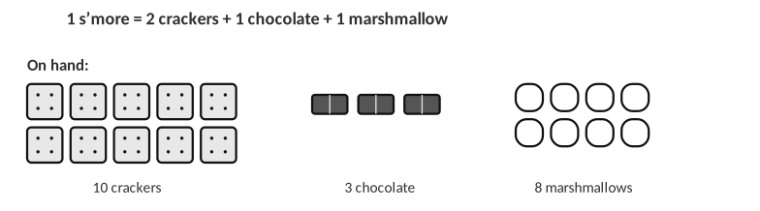
Analogy: the recipe 2 crackers : 1 chocolate : 1 marshmallow plays the role of the coefficients.
1. Use the s’more recipe. How many s’mores can you make from 6 chocolates if you have plenty of everything else? How many crackers does that use? Write the two ratios you used.
6 s’mores (1 chocolate : 1 s’more) using 12 crackers (2 crackers : 1 chocolate). The ratios are 1 s’more / 1 chocolate and 2 crackers / 1 chocolate.

2. What do you need before you can write a mole ratio? Why must the equation be balanced first?
A balanced chemical equation. The coefficients only equal the true particle ratio when the equation is balanced; an unbalanced equation would give the wrong ratio.

Write the mole ratios
Equation | Ratios (write each as a fraction)
N₂ + 3H₂ → 2NH₃ | N₂/H₂ = ______ N₂/NH₃ = ______ H₂/NH₃ = ______
8H₂ + S₈ → 8H₂S | H₂/H₂S = ______ H₂/S₈ = ______ H₂S/S₈ = ______

ANSWERS
N₂/H₂ = 1/3; N₂/NH₃ = 1/2; H₂/NH₃ = 3/2. H₂/H₂S = 8/8 = 1/1; H₂/S₈ = 8/1; H₂S/S₈ = 8/1.

3. Hydrogen gas reacts with oxygen gas to make water. (a) Write the balanced equation. (b) Write the ratios H₂/O₂, H₂/H₂O and O₂/H₂O. (c) How many moles of water form from 10 moles of hydrogen?
a. Balanced equation
2H₂ (g) + O₂ (g) → 2H₂O (l)

Answer (units & sig figs): 2H₂ + O₂ → 2H₂O
b. Mole ratios
H₂/O₂ = 2/1; H₂/H₂O = 2/2 = 1/1; O₂/H₂O = 1/2

Answer (units & sig figs):
c. Moles of water
10 mol H₂ × (2 mol H₂O / 2 mol H₂) = 1 × 10¹ mol H₂O

Answer (units & sig figs): 1 × 10¹ mol H₂O
WORKED EXAMPLE — MOLE RATIO
How many moles of NH₃ form from 4.0 mol N₂? N₂ + 3H₂ → 2NH₃

4.0 mol N₂ × (2 mol NH₃ / 1 mol N₂) = 8.0 mol NH₃

Answer: 8.0 mol NH₃
4. Use N₂ + 3H₂ → 2NH₃.
a. If 10 moles of NH₃ are produced, how many moles of N₂ were needed?
10 mol NH₃ × (1 mol N₂ / 2 mol NH₃) = 5 mol N₂

Answer (units & sig figs): 5 mol N₂
b. If 3.00 moles of H₂ are used, how many moles of NH₃ are made?
3.00 mol H₂ × (2 mol NH₃ / 3 mol H₂) = 2.00 mol NH₃

Answer (units & sig figs): 2.00 mol NH₃
c. If 0.600 moles of NH₃ are produced, how many moles of H₂ are required?
0.600 mol NH₃ × (3 mol H₂ / 2 mol NH₃) = 0.900 mol H₂

Answer (units & sig figs): 0.900 mol H₂
5. The reaction between hydrazine (N₂H₂) and hydrogen peroxide (H₂O₂) fuels rockets. The products are nitrogen gas and water. (a) Write the balanced equation. (b) How many moles of N₂ form from 37 moles of hydrazine? (c) If 23 moles of water form, how many moles of H₂O₂ were used?
a. Balanced equation
N₂H₂ (l) + H₂O₂ (l) → N₂ (g) + 2H₂O (g)

Answer (units & sig figs):
b. Moles of N₂
37 mol N₂H₂ × (1 mol N₂ / 1 mol N₂H₂) = 37 mol N₂

Answer (units & sig figs): 37 mol N₂
c. Moles of H₂O₂
23 mol H₂O × (1 mol H₂O₂ / 2 mol H₂O) = 12 mol H₂O₂

Answer (units & sig figs): 12 mol H₂O₂
TEACHER NOTE
The homework writes hydrazine as N₂H₂; real hydrazine is N₂H₄ (N₂H₄ + 2H₂O₂ → N₂ + 4H₂O, so 23 mol H₂O would need 11.5 mol H₂O₂). The key above uses the homework formula.

6.2 | Mass-to-Mass Stoichiometry Grams → moles → moles → grams

BIG IDEA
You cannot compare grams of different substances directly, because a gram of one is not the same number of particles as a gram of another. Convert to moles, use the mole ratio, then convert back to grams.

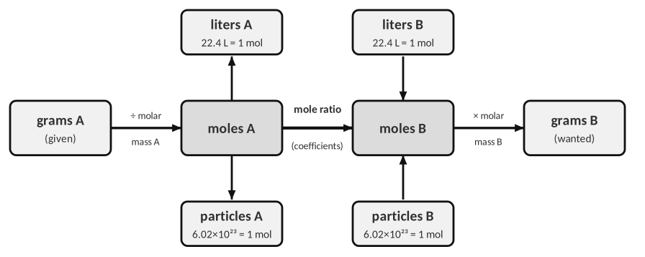
The mole map (use the top and bottom boxes in 6.3). Molar masses come from the periodic table.
1. In your own words, why is the mole ratio step the only step that uses the balanced equation? What do the other two steps use?
The mole ratio compares particles of two different substances, and only the coefficients tell us that. Converting grams to moles and back uses only each substance’s own molar mass.

SETUP RULES
1. Balance the equation. 2. Write the given quantity with its unit and substance. 3. Chain factors so that each unit cancels. 4. Round the final answer to the sig figs of the given data.

WORKED EXAMPLE — GRAMS TO GRAMS
How many grams of FeS form from 5.9 g of Fe? (8Fe + S₈ → 8FeS)

5.9 g Fe × (1 mol Fe / 55.85 g) × (8 mol FeS / 8 mol Fe) × (87.91 g FeS / 1 mol) = 9.3 g FeS

Answer: 9.3 g FeS
2. Use the equation Fe + S₈ → FeS. (a) Balance it.
a. Balance the equation
8Fe + S₈ → 8FeS

Answer (units & sig figs): 8Fe + S₈ → 8FeS
b. How many moles of FeS are produced when 2.4 g of S₈ react?
2.4 g S₈ × (1 mol S₈ / 256.48 g) × (8 mol FeS / 1 mol S₈) = 0.075 mol FeS

Answer (units & sig figs): 0.075 mol FeS
c. How many grams of iron are used if 11.9 g of sulfur (S₈) are used?
11.9 g S₈ × (1 mol S₈ / 256.48 g) × (8 mol Fe / 1 mol S₈) × (55.85 g Fe / 1 mol) = 20.7 g Fe

Answer (units & sig figs): 20.7 g Fe
3. Use the equation Fe₂O₃ + C → Fe + CO₂ (the reaction in a blast furnace).
a. Balance the equation
2Fe₂O₃ + 3C → 4Fe + 3CO₂

Answer (units & sig figs): 2Fe₂O₃ + 3C → 4Fe + 3CO₂
b. How many grams of iron form if 39.64 g of carbon are used?
39.64 g C × (1 mol C / 12.01 g) × (4 mol Fe / 3 mol C) × (55.85 g Fe / 1 mol) = 245.8 g Fe

Answer (units & sig figs): 245.8 g Fe
c. If 63.12 g of iron(III) oxide are used, how many grams of carbon dioxide form?
63.12 g Fe₂O₃ × (1 mol Fe₂O₃ / 159.70 g) × (3 mol CO₂ / 2 mol Fe₂O₃) × (44.01 g CO₂ / 1 mol) = 26.09 g CO₂

Answer (units & sig figs): 26.09 g CO₂
4. A student solved “grams of Fe₂O₃ → grams of CO₂” by multiplying by 159.7 g/mol and then by 44.01 g/mol, skipping the mole ratio. Describe what is wrong and what the student’s answer would represent.
The student never converted grams of Fe₂O₃ to moles and never used the mole ratio (2 Fe₂O₃ : 3 CO₂), so the units do not cancel. Grams of one substance cannot be converted directly into grams of another; the coefficients only connect moles.

5. To convert grams of A to grams of B you need…
A) molar masses only B) molar masses and the mole ratio C) the mole ratio only D) 22.4 L/mol
6.3 | Liters and Particles Gas volume at STP and counting atoms

BIG IDEA
At STP (0 °C and 1 atm), 1 mole of any gas occupies 22.4 L. This lets us convert between liters of a gas and moles, and so to any other substance. One mole is also 6.02 × 10²³ particles.

Key vocabulary — write each definition in your own words
Term | Definition (your words) | Example / sketch
STP | Standard temperature and pressure: 0 °C and 1 atm; 1 mol of any gas occupies 22.4 L. | 5.60 L of O₂ = 0.250 mol
Molar volume | The volume of one mole of gas (22.4 L/mol at STP); it is the same for every ideal gas. | 22.4 L/mol

THINK OF IT LIKE… A DOZEN IS JUST A NUMBER
A dozen is 12 things, whether they are eggs or elephants. A mole is 6.02 × 10²³ things, and at STP that many gas molecules take up 22.4 L whether they are H₂ or Cl₂. Gases are mostly empty space, so the size of the molecule hardly matters.

1. Explain why 1 mole of H₂ and 1 mole of Cl₂ occupy the same volume at STP even though a Cl₂ molecule is much heavier.
At STP the gas molecules are far apart (mostly empty space), so the volume depends on the number of particles, not on their size or mass. Equal numbers of particles occupy equal volumes.

2. Hydrogen gas and oxygen gas combine to form water. Assume STP.
a. How many liters of H₂ are needed to make 3 moles of water?
3 mol H₂O × (2 mol H₂ / 2 mol H₂O) × (22.4 L H₂ / 1 mol) = 7 × 10¹ L H₂

Answer (units & sig figs): 7 × 10¹ L H₂
b. How many grams of water form from 30.2 L of hydrogen?
30.2 L H₂ × (1 mol H₂ / 22.4 L) × (2 mol H₂O / 2 mol H₂) × (18.02 g H₂O / 1 mol) = 24.3 g H₂O

Answer (units & sig figs): 24.3 g H₂O
c. How many grams of water form from 30.2 L of oxygen?
30.2 L O₂ × (1 mol O₂ / 22.4 L) × (2 mol H₂O / 1 mol O₂) × (18.02 g H₂O / 1 mol) = 48.6 g H₂O

Answer (units & sig figs): 48.6 g H₂O
d. When 120.3 g of water form, how many liters of hydrogen were used?
120.3 g H₂O × (1 mol H₂O / 18.02 g) × (2 mol H₂ / 2 mol H₂O) × (22.4 L H₂ / 1 mol) = 149.5 L H₂

Answer (units & sig figs): 149.5 L H₂
LAB CORNER • Sodium azide in a car air bag

A crash sensor sets off the reaction NaN₃(s) → Na(l) + N₂(g). The nitrogen gas inflates the bag in about 0.03 seconds.
[ IMAGE GOES HERE ]
Photo or diagram of an air bag inflator (add your own)

3. Balance the equation, then solve (STP).
a. Balance the equation
2NaN₃ (s) → 2Na (l) + 3N₂ (g)

Answer (units & sig figs): 2NaN₃ (s) → 2Na (l) + 3N₂ (g)
b. How many liters of N₂ form from 15.62 g of NaN₃?
15.62 g NaN₃ × (1 mol NaN₃ / 65.02 g) × (3 mol N₂ / 2 mol NaN₃) × (22.4 L N₂ / 1 mol) = 8.072 L N₂

Answer (units & sig figs): 8.072 L N₂
c. How many grams of NaN₃ are needed to produce 200.0 L of N₂?
200.0 L N₂ × (1 mol N₂ / 22.4 L) × (2 mol NaN₃ / 3 mol N₂) × (65.02 g NaN₃ / 1 mol) = 387.0 g NaN₃

Answer (units & sig figs): 387.0 g NaN₃
d. If 31.4 g of sodium are produced, how many liters of N₂ are produced?
31.4 g Na × (1 mol Na / 22.99 g) × (3 mol N₂ / 2 mol Na) × (22.4 L N₂ / 1 mol) = 45.9 L N₂

Answer (units & sig figs): 45.9 L N₂
TEACHER NOTE
The homework says “sodium nitride”; NaN₃ is sodium azide.

4. How many molecules of water form from 5.0 g of hydrogen gas? (2H₂ + O₂ → 2H₂O; 1 mol = 6.02 × 10²³ molecules)
5.0 g H₂ × (1 mol H₂ / 2.02 g) × (2 mol H₂O / 2 mol H₂) × (6.02 × 10²³ molecules / 1 mol) = 1.5 × 10²⁴ molecules H₂O

Answer (units & sig figs): 1.5 × 10²⁴ molecules H₂O
LAB CORNER • Hydrogen gas collected over water

A 0.150 g strip of magnesium reacts completely with excess hydrochloric acid. The hydrogen is collected in an inverted graduated cylinder.
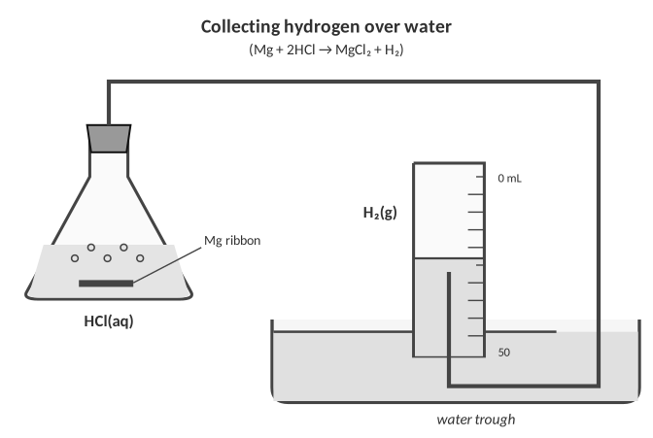
5. (a) Write the balanced equation. (b) Calculate the theoretical volume of H₂ at STP in mL. (c) The measured volume was 128 mL. Name one reason it differs.
a. Equation
Mg (s) + 2HCl (aq) → MgCl₂ (aq) + H₂ (g)

Answer (units & sig figs): Mg (s) + 2HCl (aq) → MgCl₂ (aq) + H₂ (g)
b. Theoretical volume
0.150 g Mg × (1 mol Mg / 24.31 g) × (1 mol H₂ / 1 mol Mg) × (22.4 L H₂ / 1 mol) = 0.138 L = 138 mL

Answer (units & sig figs): 138 mL H₂
c. Reason
Some gas stays dissolved or in the tubing; the room is not at STP (T and P differ); water vapor is mixed in with the H₂; the Mg may not be pure.

Answer (units & sig figs):
6.4 | Limiting and Excess Reactants Which ingredient runs out first?

BIG IDEA
Reactants are almost never mixed in perfect recipe amounts. The limiting reactant is the one that runs out first and so decides how much product forms. The excess reactant is what is left over when the reaction stops.

Key vocabulary — write each definition in your own words
Term | Definition (your words) | Example / sketch
Limiting reactant | The reactant that is completely used up first; it determines the maximum amount of product. | Chocolate in the s’more example
Excess reactant | The reactant present in more than the amount needed; some is left over after the reaction. | Crackers and marshmallows

Recipe: 2 crackers + 1 chocolate + 1 marshmallow → 1 s’more.
1. Using the s’more recipe and the items shown: (a) How many s’mores can you make? (b) What is the limiting “reactant”? (c) What is left over, and how many of each?
(a) Crackers allow 10 ÷ 2 = 5; chocolate allows 3; marshmallows allow 8. The smallest is 3, so 3 s’mores.
(b) Chocolate is limiting.
(c) Crackers used 6, so 4 left; marshmallows used 3, so 5 left. Chocolate: 0 left.

BCA TABLE STEPS (MOLES!)
1. Balance the equation. Convert every given amount to moles.
2. Divide each by its coefficient; the smallest value is the limiting reactant.
3. Before row = starting moles. Change row = the limiting reactant goes to 0; use the mole ratio for the rest (reactants −, products +).
4. After row = Before + Change. Convert the After amounts to the unit the question asks for.

Particle picture: N₂ + 3H₂ → 2NH₃
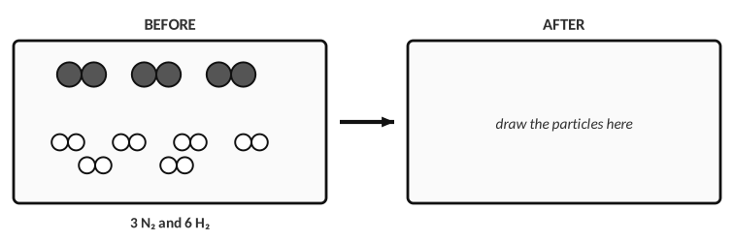
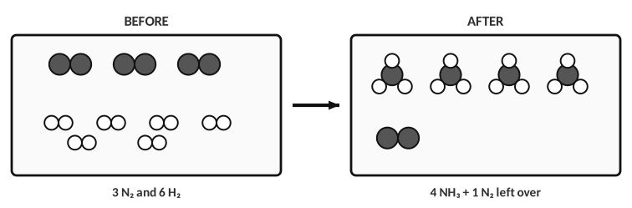
Answer: 6 H₂ react with 2 N₂ to make 4 NH₃; hydrogen is limiting and 1 N₂ is left over.
2. Which reactant is limiting? Draw the particles after the reaction in the AFTER box, then say how many N₂ molecules are left.
H₂ is limiting (6 H₂ need only 2 N₂; 3 N₂ are available). After: 4 NH₃ and 1 N₂ left over.

WORKED EXAMPLE — BCA TABLE
1.5 mol CH₄ react with 2.5 mol Cl₂: CH₄ + 2Cl₂ → CH₂Cl₂ + 2HCl. Find the moles of each product and the moles of excess reactant left.

(mol) | CH₄ | 2Cl₂ | CH₂Cl₂ | 2HCl
Before | 1.50 | 2.50 | 0 | 0
Change | -1.25 | -2.50 | +1.25 | +2.50
After | 0.250 | 0 | 1.25 | 2.50

Limiting reactant: Cl₂ (it gives the smallest amount of reaction, 1.3 “equation units”).
CH₂Cl₂ produced: 1.3 mol = 1.3 mol
HCl produced: 2.5 mol = 2.5 mol
CH₄ left over: 0.25 mol = 0.25 mol

3. 15.0 g of N₂ gas reacts with 4.50 g of H₂ gas: N₂ + 3H₂ → 2NH₃. Use a BCA table to find the mass of NH₃ made and the mass of the excess reactant left.
(mol) | N₂ | 3H₂ | 2NH₃
Before | 0.535 | 2.23 | 0
Change | -0.535 | -1.61 | +1.07
After | 0 | 0.622 | 1.07

Limiting reactant: N₂ (it gives the smallest amount of reaction, 0.535 “equation units”).
NH₃ produced: 1.07 mol = 18.2 g
N₂ left over: 0 mol = 0 g
H₂ left over: 0.622 mol = 1.26 g

4. 17.5 L of NH₃ gas react with 12.5 L of O₂ gas at STP: 4NH₃ (g) + 5O₂ (g) → 4NO (g) + 6H₂O (g). Use a BCA table to find the mass of each product and the liters of excess reactant left.
(mol) | 4NH₃ | 5O₂ | 4NO | 6H₂O
Before | 0.781 | 0.558 | 0 | 0
Change | -0.446 | -0.558 | +0.446 | +0.670
After | 0.335 | 0 | 0.446 | 0.670

Limiting reactant: O₂ (it gives the smallest amount of reaction, 0.112 “equation units”).
NO produced: 0.446 mol = 13.4 g
H₂O produced: 0.670 mol = 12.1 g
NH₃ left over: 0.335 mol = 7.50 L

5. 7.50 g of solid sodium react with 18.5 L of Cl₂ gas at STP: 2Na (s) + Cl₂ (g) → 2NaCl (s). Find the mass of NaCl made and the mass of the excess reactant left.
(mol) | 2Na | Cl₂ | 2NaCl
Before | 0.326 | 0.826 | 0
Change | -0.326 | -0.163 | +0.326
After | 0 | 0.663 | 0.326

Limiting reactant: Na (it gives the smallest amount of reaction, 0.163 “equation units”).
NaCl produced: 0.326 mol = 19.1 g
Cl₂ left over: 0.663 mol = 47.0 g

6. A classmate says, “The limiting reactant is the one with the smaller mass.” Use any example above to show why this is not reliable.
Limiting depends on moles divided by coefficient, not mass. In the N₂/H₂ problem H₂ has the smaller mass (4.50 g vs 15.0 g) and is limiting, but in the sodium/chlorine problem the Cl₂ has far more mass (47 g vs 7.5 g) and is the excess. Different substances have different molar masses and different coefficients.

7. In a BCA table, the limiting reactant’s “After” value is always…
A) equal to its Before value B) zero C) equal to the product D) negative
6.5 | Theoretical, Actual and Percent Yield How well did the lab go?

BIG IDEA
The theoretical yield is the most product the equation predicts (from the limiting reactant). The actual yield is what you really collect in the lab. Percent yield = actual ÷ theoretical × 100, and it can never honestly be more than 100 %.

Key vocabulary — write each definition in your own words
Term | Definition (your words) | Example / sketch
Theoretical yield | The maximum amount of product calculated from the balanced equation and the limiting reactant. | 8.78 g Al(OH)₃
Actual yield | The amount of product actually obtained and measured in an experiment. | 7.30 g Al(OH)₃
Percent yield | The actual yield divided by the theoretical yield, times 100. | 7.30 / 8.78 × 100 = 83.1 %

THINK OF IT LIKE… FREE THROWS
A player who shoots 10 free throws could, in theory, make all 10 (theoretical yield). Making 8 is the actual yield, so the percent yield is 80 %. Nobody can make 12 out of 10, so a percent yield over 100 % means something is wrong.

LAB CORNER • Collecting a precipitate

A student mixes two solutions, filters the solid, dries it and finds its mass.
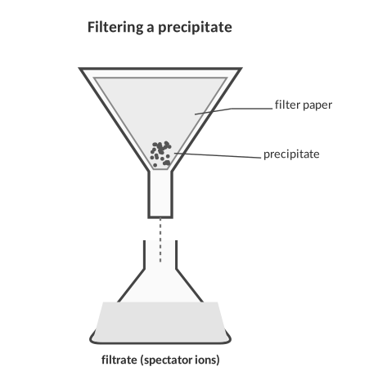
1. Give three reasons the actual yield of a precipitate is usually less than the theoretical yield. Then give one reason a student might get a percent yield greater than 100 %.
Less: some precipitate stays on the glassware or filter paper; some dissolves a little (not perfectly insoluble); incomplete reaction; side reactions; spills; impure reactants. More than 100 %: the solid was not completely dry (water mass counted) or was contaminated with another substance.

2. Methane burns: CH₄ + 2O₂ → CO₂ + 2H₂O.
a. A student reacts 10.0 g of O₂ with excess CH₄. Calculate the theoretical yield of CO₂.
10.0 g O₂ × (1 mol O₂ / 32.00 g) × (1 mol CO₂ / 2 mol O₂) × (44.01 g CO₂ / 1 mol) = 6.88 g CO₂

Answer (units & sig figs): 6.88 g CO₂
b. The lab produces 6.50 g of CO₂. Calculate the percent yield.
6.50 g / 6.88 g × 100 = 94.5 %

Answer (units & sig figs): 94.5 %
3. CaCl₂ (aq) + 2AgNO₃ (aq) → Ca(NO₃)₂ (aq) + 2AgCl (s)
a. A student reacts 15.0 g of CaCl₂ with 10. g of AgNO₃. Find the limiting reactant and the theoretical yield of AgCl.
Moles: CaCl₂ 0.135, AgNO₃ 0.059. AgNO₃ gives less (÷2), so it is limiting.
0.059 mol AgNO₃ × (2 mol AgCl / 2 mol AgNO₃) × (143.32 g / 1 mol) = 8.4 g

Answer (units & sig figs): 8.4 g AgCl
b. 4.50 g of AgCl are obtained. Find the percent yield.
4.50 g / 8.4 g × 100 = 54 %

Answer (units & sig figs): 54 %
4. AlCl₃ + 3NaOH → Al(OH)₃ + 3NaCl
a. 15.0 g of AlCl₃ react with 20.0 g of NaOH. Find the limiting reactant and the theoretical yield of Al(OH)₃.
Moles: AlCl₃ 0.113, NaOH 0.500; ÷ coefficients: 0.113 vs 0.167. AlCl₃ is limiting.
0.113 mol × (1/1) × (78.01 g/mol) = 8.78 g

Answer (units & sig figs): 8.78 g Al(OH)₃
b. 7.30 g of Al(OH)₃ are collected. Find the percent yield.
7.30 g / 8.78 g × 100 = 83.1 %

Answer (units & sig figs): 83.1 %
5. A reaction has a theoretical yield of 25.0 g. A student collects 21.0 g. The percent yield is…
A) 84.0 % B) 119 % C) 16.0 % D) 46.0 g
PRACTICE
Extra Practice — Unit 6
Show every setup with units.

A. Mole ratios and mass-to-mass
1. Use K₃PO₄ + Al(NO₂)₃ → 3KNO₂ + AlPO₄.
a. How many grams of KNO₂ form from 4.6 mol of K₃PO₄?
4.6 mol K₃PO₄ × (3 mol KNO₂ / 1 mol K₃PO₄) × (85.11 g KNO₂ / 1 mol) = 1.2 × 10³ g KNO₂

Answer (units & sig figs): 1.2 × 10³ g KNO₂
b. If 5.8 g of AlPO₄ form, how many grams of Al(NO₂)₃ were used?
5.8 g AlPO₄ × (1 mol AlPO₄ / 121.95 g) × (1 mol Al(NO₂)₃ / 1 mol AlPO₄) × (165.01 g Al(NO₂)₃ / 1 mol) = 7.8 g Al(NO₂)₃

Answer (units & sig figs): 7.8 g Al(NO₂)₃
c. How many grams of KNO₂ form from 6.2 g of K₃PO₄?
6.2 g K₃PO₄ × (1 mol K₃PO₄ / 212.27 g) × (3 mol KNO₂ / 1 mol K₃PO₄) × (85.11 g KNO₂ / 1 mol) = 7.5 g KNO₂

Answer (units & sig figs): 7.5 g KNO₂
2. Use CO + 2H₂ → CH₃OH.
a. If 5.7 g of CO are used, how many grams of H₂ are also used?
5.7 g CO × (1 mol CO / 28.01 g) × (2 mol H₂ / 1 mol CO) × (2.02 g H₂ / 1 mol) = 0.82 g H₂

Answer (units & sig figs): 0.82 g H₂
b. If 0.89 g of H₂ are used, how many grams of CH₃OH form?
0.89 g H₂ × (1 mol H₂ / 2.02 g) × (1 mol CH₃OH / 2 mol H₂) × (32.05 g CH₃OH / 1 mol) = 7.1 g CH₃OH

Answer (units & sig figs): 7.1 g CH₃OH
c. If 15.0 L of CO are used at STP, how many liters of H₂ are also used? Why is no molar mass needed?
15.0 L CO × (1 mol CO / 22.4 L) × (2 mol H₂ / 1 mol CO) × (22.4 L H₂ / 1 mol) = 30.0 L H₂

Answer (units & sig figs): 30.0 L H₂
TEACHER NOTE
(c) Equal volumes of gases at the same T and P are equal numbers of moles, so liters convert with the coefficients alone (Avogadro). 15.0 L CO × (2 mol H₂/1 mol CO) = 30.0 L H₂.

B. Limiting reactant and percent yield
3. 10.0 g of Al react with 20.0 g of Cl₂: 2Al + 3Cl₂ → 2AlCl₃. Which is limiting, and how many grams of AlCl₃ can form? How much of the excess reactant is left?
(mol) | 2Al | 3Cl₂ | 2AlCl₃
Before | 0.371 | 0.282 | 0
Change | -0.188 | -0.282 | +0.188
After | 0.183 | 0 | 0.188

Limiting reactant: Cl₂ (it gives the smallest amount of reaction, 0.0940 “equation units”).
AlCl₃ produced: 0.188 mol = 25.1 g
Al left over: 0.183 mol = 4.93 g

4. 6.54 g of Zn react with 0.150 mol of HCl: Zn + 2HCl → ZnCl₂ + H₂. Find the liters of H₂ at STP that can form and the grams of the excess reactant left.
(mol) | Zn | 2HCl | ZnCl₂ | H₂
Before | 0.100 | 0.150 | 0 | 0
Change | -0.0750 | -0.150 | +0.0750 | +0.0750
After | 0.0250 | 0 | 0.0750 | 0.0750

Limiting reactant: HCl (it gives the smallest amount of reaction, 0.0750 “equation units”).
H₂ produced: 0.0750 mol = 1.68 L
Zn left over: 0.0250 mol = 1.64 g

5. A student burns 4.86 g of Mg in air: 2Mg + O₂ → 2MgO. The white powder has a mass of 7.60 g.
a. Calculate the theoretical yield of MgO.
4.86 g Mg × (1 mol Mg / 24.31 g) × (2 mol MgO / 2 mol Mg) × (40.31 g MgO / 1 mol) = 8.06 g MgO

Answer (units & sig figs): 8.06 g MgO
b. Calculate the percent yield and suggest a reason it differs from 100 %.
7.60 / 8.06 × 100 = 94.3 %. Some MgO smoke escaped, or some Mg formed Mg₃N₂ with nitrogen in the air.

Answer (units & sig figs): 94.3 %
C. Lab data
6. A student mixes 2.12 g of Na₂CO₃ (in water) with excess CaCl₂ solution: Na₂CO₃ (aq) + CaCl₂ (aq) → CaCO₃ (s) + 2NaCl (aq). The precipitate is filtered, dried and weighed. Data: filter paper 0.86 g; filter paper + dry solid 2.76 g.
(a) Mass of CaCO₃ collected: 2.76 − 0.86 = 1.90 g.
(b) Theoretical: 2.12 g Na₂CO₃ × (1 mol Na₂CO₃ / 105.99 g) × (1 mol CaCO₃ / 1 mol Na₂CO₃) × (100.09 g CaCO₃ / 1 mol) = 2.00 g CaCO₃
(c) Percent yield: 1.90 / 2.00 × 100 = 95.0 %

D. Think
7. A recipe makes 24 cookies from 2 cups of flour. You have 5 cups of flour but only 3 eggs, and the recipe needs 1 egg per 8 cookies. How many cookies can you make, and what is the limiting ingredient? Relate this to a chemical reaction.
Eggs: 3 × 8 = 24 cookies. Flour: 5 / 2 × 24 = 60 cookies. Eggs limit, so 24 cookies. In a reaction, the reactant that gives the least product is limiting, just as the eggs are.

8. Why must you convert to moles before deciding which reactant is limiting?
The equation compares particles (moles), not grams; equal masses of two substances are different numbers of particles.

9. N₂ + 3H₂ → 2NH₃. If 4 mol N₂ and 9 mol H₂ are mixed, the limiting reactant is…
A) N₂ B) H₂ C) NH₃ D) neither
10. Which quantity cannot be negative or over 100 % in a lab report?
A) percent yield B) actual yield minus theoretical C) mole ratio D) Change in a BCA table
Unit 6 review
11. Write the complete plan (in words) for solving “grams of A → grams of B”. Then say what changes for “liters of gas A → grams of B”.
Balance; grams A ÷ molar mass A = mol A; × (coefficient B / coefficient A) = mol B; × molar mass B = grams B. For liters of A, replace the first step with liters ÷ 22.4 L/mol (at STP).

12. Describe how you find the limiting reactant and how you use it to find the product and the leftover.
Convert each reactant to moles and divide by its coefficient; the smallest quotient is limiting. Use the limiting reactant’s moles with the mole ratio to get product; subtract what was used from the excess reactant’s starting moles to find the leftover.

Sources & further reading
• PhET – Reactants, Products and Leftovers simulation (University of Colorado Boulder) — https://phet.colorado.edu/en/simulations/reactants-products-and-leftovers
• LibreTexts – Introductory Chemistry (CK-12), Chapter 12: Stoichiometry — https://chem.libretexts.org/Bookshelves/Introductory_Chemistry/Introductory_Chemistry_%28CK-12%29/12%3A_Stoichiometry
• LibreTexts – Chemistry 2e (OpenStax), 4.4 Reaction Yields — https://chem.libretexts.org/Bookshelves/General_Chemistry/Chemistry₂e_(OpenStax)/04%3A_Stoichiometry_of_Chemical_Reactions/4.04%3A_Reaction_Yields

